Below are the steps you need to take before the 1st day of school!!

Schoology New students must first create an account in Office 365.
1. Log into http://portal.office.com
2. Enter their EPISD Email and Password (YYYYMMDD) as prompted ( eg: bmanilo@episd.org and 19430714)
3. Once in Office 365, click FIRST on OneDrive. This sets up their Office 365 accounts and takes a minute or two. Failure to click on OneDrive will result in an error message later.
4. Once they have an Office 365 account, they are good to log into Schoology.

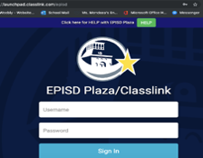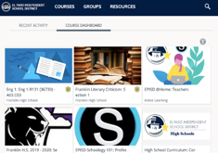
Under Launchpad click on the EPISD Plaza Icon
- Login using your credential
Username – the first part of your email address
Password – your birthdate (YYYYMMDD)
- Click on Schoology – Login
- You will see your Course Dashboard
- Click on your class
- If you cannot login please contact the help desk at 915-230-2601 or your teacher can submit a Zendesk ticket for you. You can also call 915-236-2500 for assistance in submitting a ticket.

Daily Virtual Bell Schedule Click Here

Class Calendar – Orange/Black/White Days Click Here

Laptops

New Students – please email cmrodri3@episd.org – please provide students Full Name, ID number and a good contact phone number. TIS will contact you to set up an appointment for you

Returning students with computers issues i.e. won’t charge, won’t turn on, can’t log on please email cmrodri3@episd.org include students full name, ID number and a good contact phone number or call the school at 915-236-2500 and we will create a Zendesk ticket for you.

Lunch – Pick Up Drop Off Zone on Schuster

Monday, August 17th – Wednesday, August 19th distribution will be from 11 am – 4 pm
Thursday, August 20th & Friday, August 21st distribution will be from 11:30 am – 1:30 pm
Beginning August 24th the schedule will be Monday - Friday 11:30 am - 1:30 pm

Student and Parent Portal Login Steps Click here
Issues with logging into student portal please call Ms. Hernandez at 915-317-6380

El Paso High School Contact List Click Here

